# **Rental Car Website**

**Vision**

This is website for car rent – Vlada’sCars.com. There are many cars of various brands in your fleet, user/guest can choose a car for rent according to his requirements (using filters on the website) at a specific time and date.

Application use cases:

* User:
  + Log in, Log out
  + Search cars
  + View car details
  + Calculate price for user’s rent period of time
  + Rent cars
  + Payment details
  + Booking cancelation
  + View car(s) currently rented by the user
  + Add feedback
* Admin:
  + Log in, Log out
  + CRUD cars
  + Answer feedback
  + Delete feedback (rude comments moderation)
* Guest:
  + Search
  + Registration

1. **Guest**

There is use case diagram for Guest: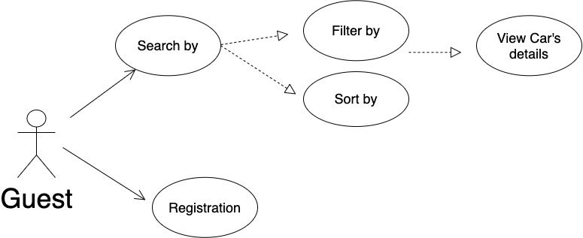

**Registration**

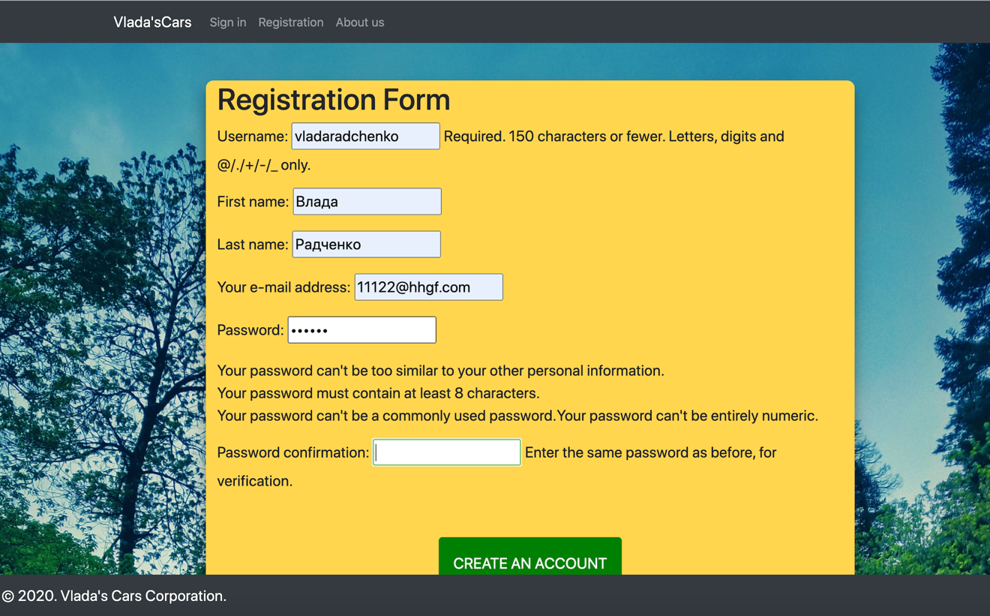

**Search page**

**Filter by**: Car Type, Car Specification(), Pick up location(airport, non-airport), Number of passengers, Full policy

***Filters***

Car Type:(Dropdown)

✓Economy(check-box)

✓Mini

✓Standart

✓SUV

✓Passanger Van

Fuel policy:(Dropdown)

✓Full to Full(check-box)

Passenger:(Dropdown)

* ✓1 to 2 passengers (check-box)
* ✓2 to 4 passangers ✓5 to 8 passangers
* ✓8 to 12 passangers

Price:

* ✓less 50$ (check-box)
* ✓ 50 - 100$
* ✓100 -200$
* ✓Greater than 200$

Car Specifications:(Dropdown)

* ✓With Air-conditioning (check-box)
* ✓Automatic Transmission
* ✓Manual gearbox
* ✓4+ Doors

***Sort by:***

• Recommended (Check-box)

• Price: low to high / high to low (Dropdown)

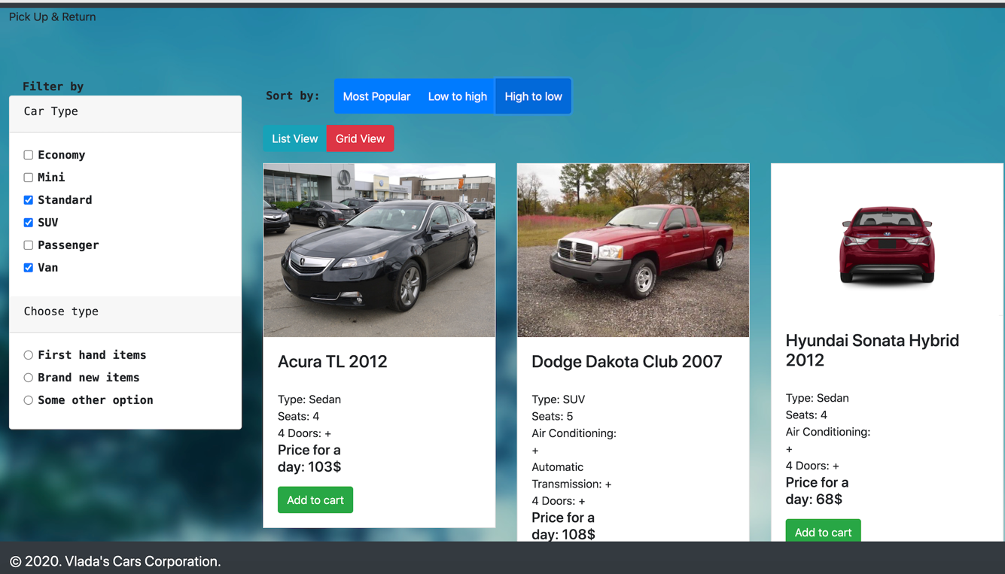

**Features:** pagination

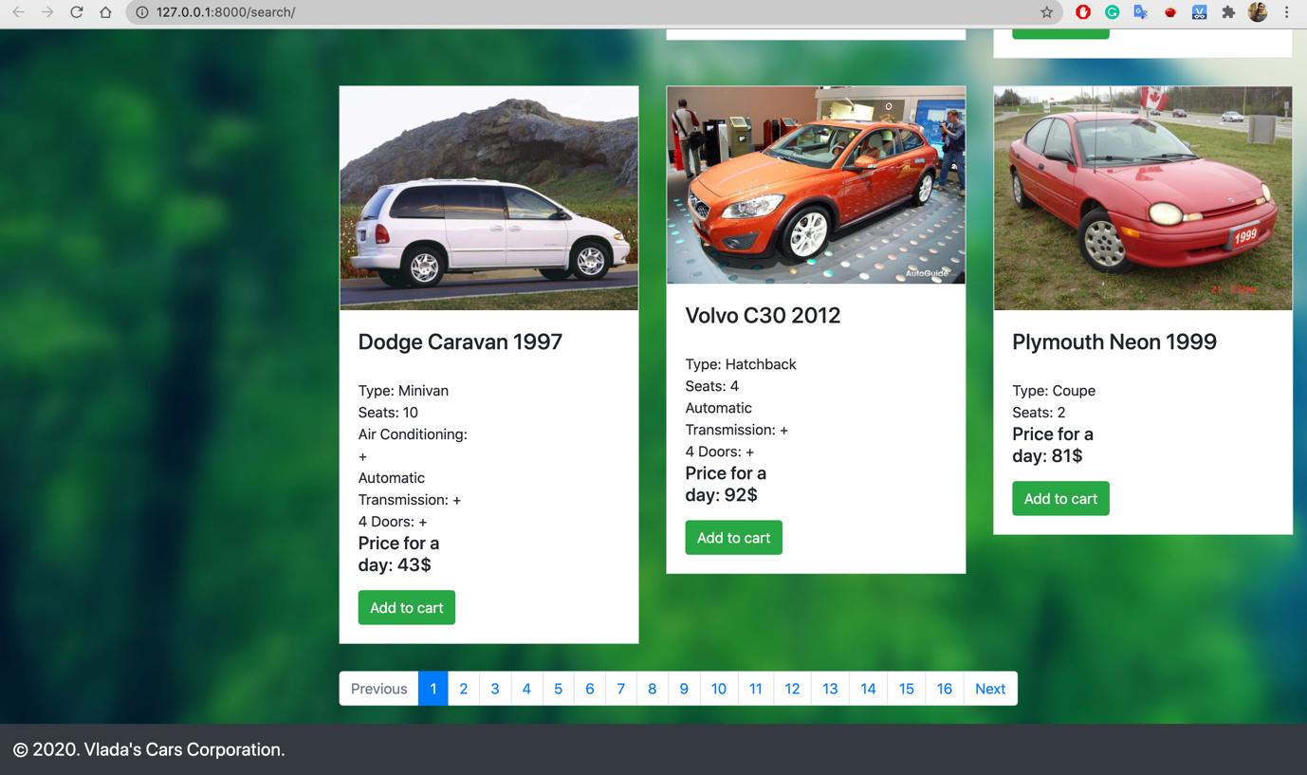

**Main page, Pick up/ Drop off(date) & Time**

**Search by**: Pick up/ Drop off(place), Pick up/ Drop off(date), Time

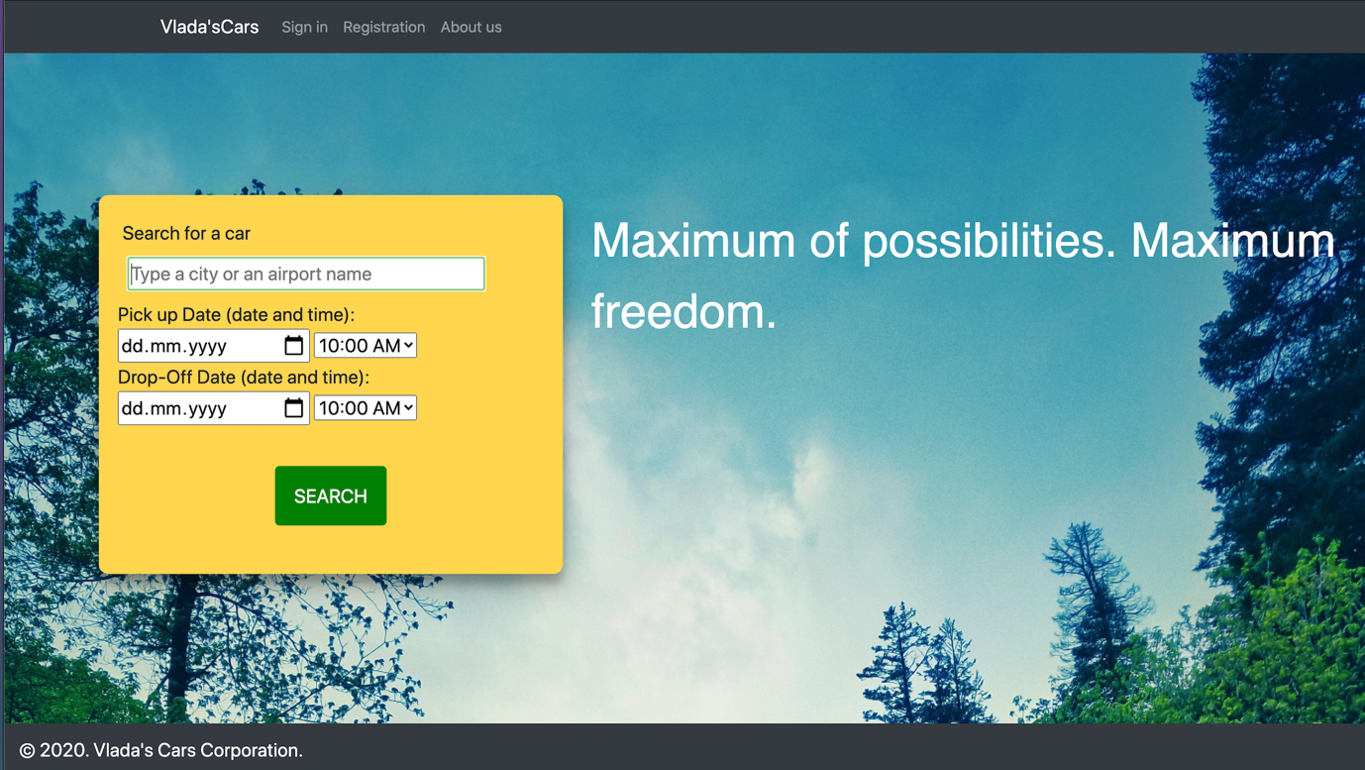

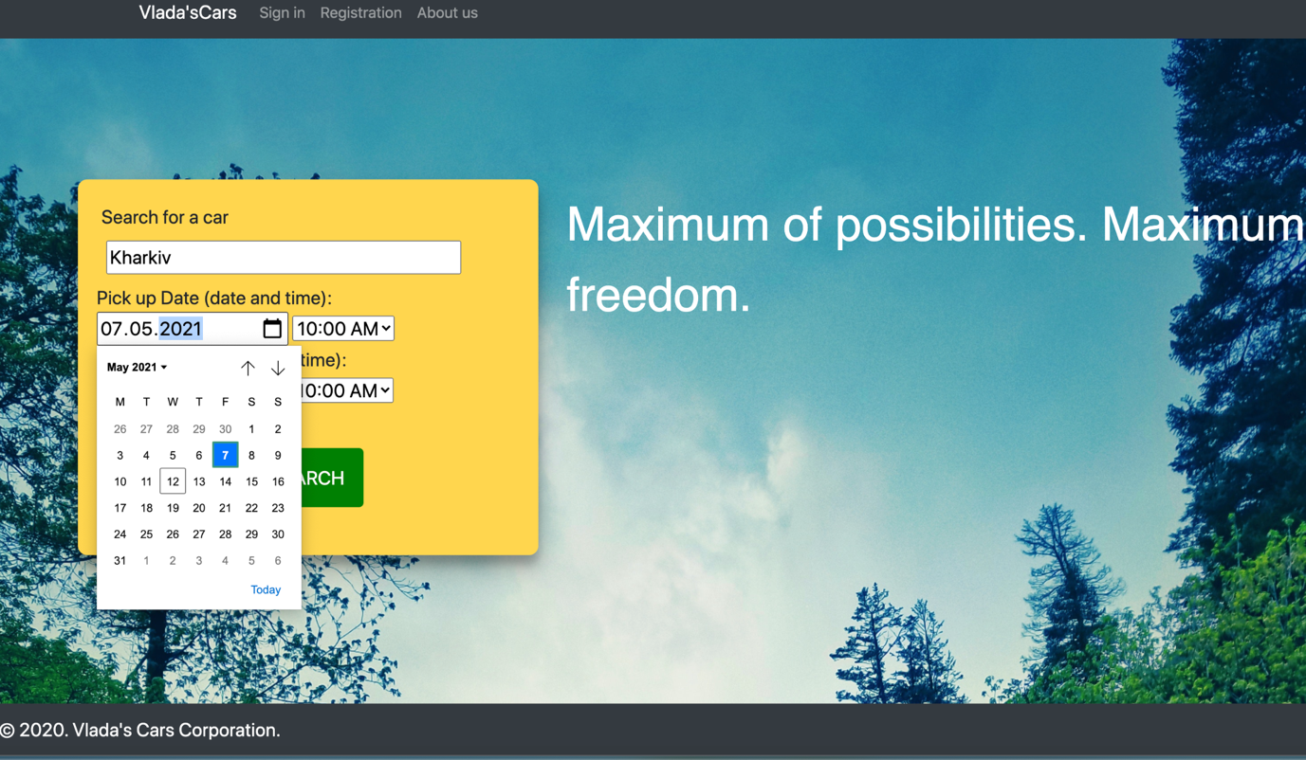

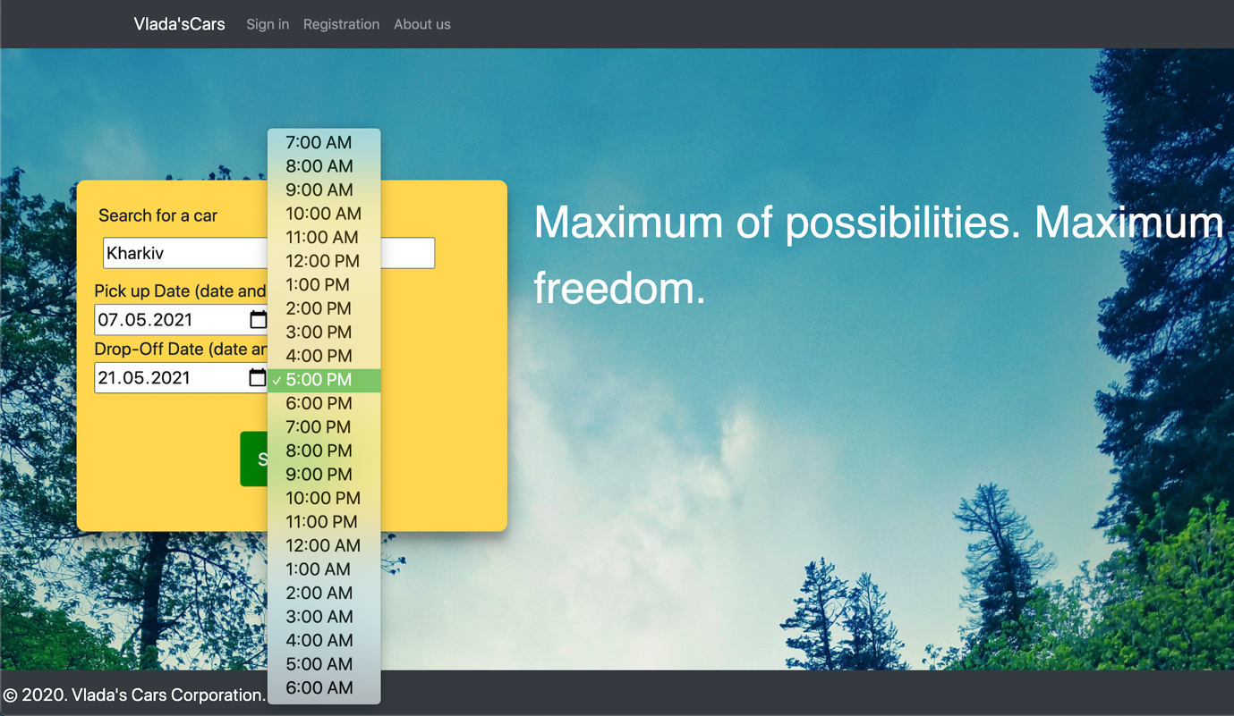

**2. User**

There is use case diagram for User:

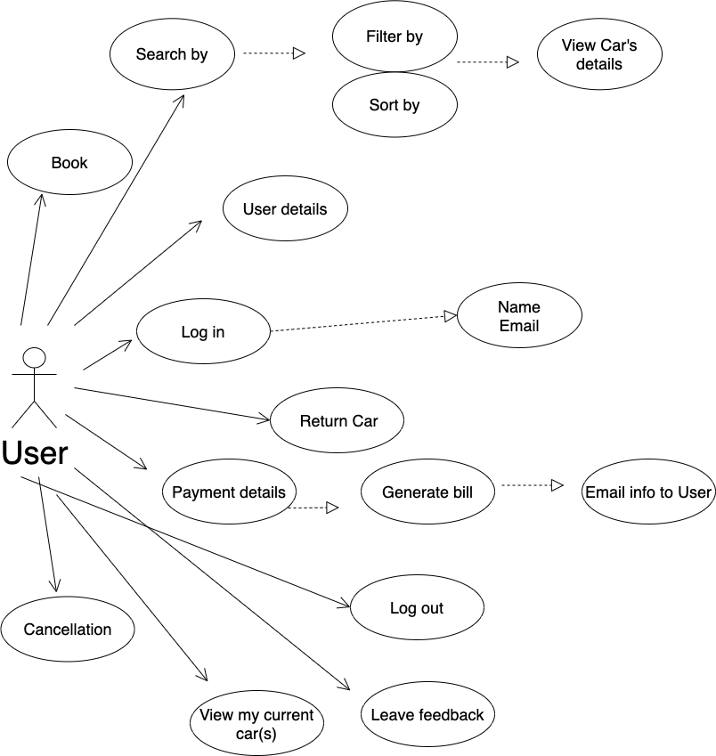

**Main page**

Log in

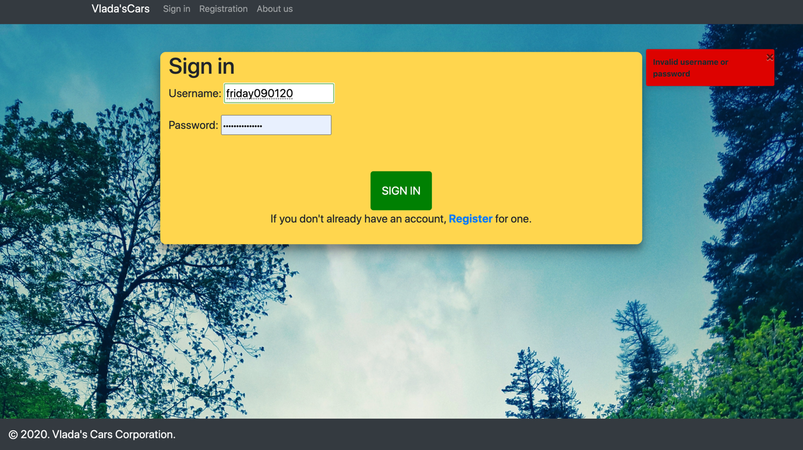

Log out – press button “Logout” in the header of page.

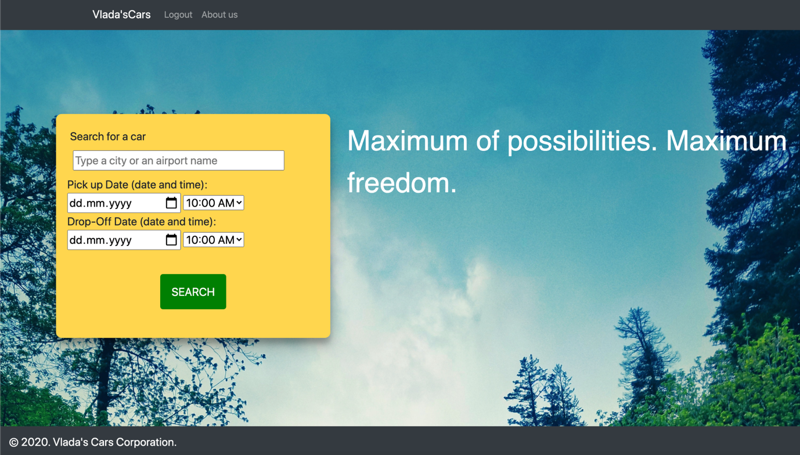

**Filter by:** (the same as for Guest)

**Sort by:** (the same as for Guest)

**Return car:** form with (rating, feedback, damage, etc.)

**3. Admin**

There is use case diagram for Admin:

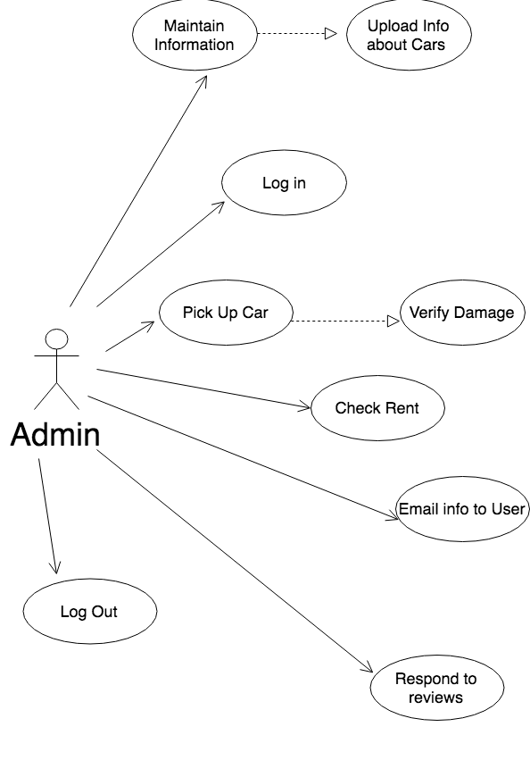  
**Log In and log out**

